**Blue Team: Summary of Operations**

**Table of Contents**

* Network Topology
* Description of Targets
* Monitoring the Targets
* Patterns of Traffic and Behaviour
* Suggestions for Going Further

**Network Topology**

The following machines were identified on the network:

**Kali**

* Operating System:
  + Debian Kali 5.4.0
* Purpose:
  + The attacking machine
* IP Address:
  + 192.168.1.90

**ELK**

* Operating System:
  + Ubuntu 18.04
* Purpose:
  + The ELK (Elasticsearch and Kibana) Stack
* IP Address:
  + 192.168.1.100

**Target 1**

* Operating System:
  + Debian GNU/Linux 8
* Purpose:
  + The WordPress Host
* IP Address:
  + 192.168.1.110

**Capstone**

* Operating System:
  + Ubuntu 18.04
* Purpose:
  + The Vulnerable Web Server
* IP Address:
  + 192.168.1.105

**Network Diagram:**

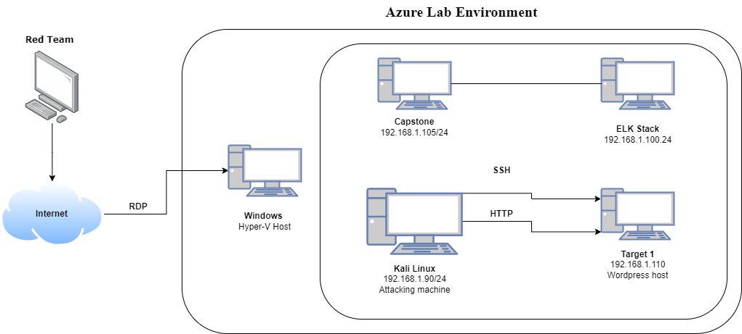

**Description of Targets**

* Two VMs on the network were vulnerable to attack: Target 1 (192.168.1.110) and Target 2 (192.168.1.115). However, only Target 1 is covered and was attacked.
* Each VM functions as an Apache web server and has SSH enabled, so ports 80 and 22 are possible ports of entry for attackers.

**Monitoring the Targets**

This scan identifies the services below as potential points of entry:

**Target 1**

* Port 22/TCP Open SSH OpenSSH 6.7p1 Debian 5+deb8u4
* Port 80/TCP Open HTTP Apache httpd 2.4.10 (Debian)

Traffic to these services should be carefully monitored. To this end, we have implemented the alerts below:

**Excessive HTTP Errors**

Excessive HTTP Errors is implemented as follows:

WHEN **count()** GROUPED OVER **top 5 'http.response.status_code'** IS ABOVE 400 FOR THE LAST **5 minutes**

* Metric:
  + WHEN count() GROUPED OVER top 5 ‘http.response.status_code’
* Threshold:
  + IS ABOVE 400
* Vulnerability Mitigated:
  + Enumeration/Brute Force
* Reliability:
  + This alert is highly reliable. Filtering by error codes 400 and above will filter out any normal or successful responses. Error codes in the 400’s are server and client error codes which are of concern.

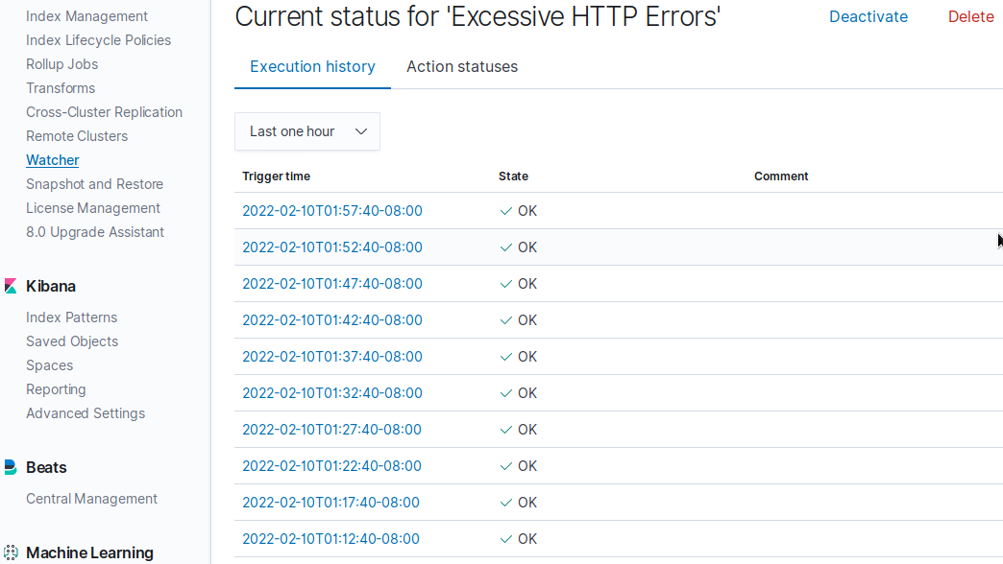

**HTTP Request Size Monitor**

HTTP Request Size Monitor is implemented as follows:

WHEN **sum() of http.request.bytes** OVER **all documents** IS ABOVE 3500 FOR THE LAST **1 minute**

* Metric:
  + WHEN sum() of http.request.bytes OVER all documents
* Threshold:
  + IS ABOVE 3500
* Vulnerability Mitigated:
  + Code injection in HTTP requests (XSS and CRLF) or DDOS
* Reliability:
  + This alert could create false positives. Because of this it is only fairly reliable. There could be confusion between malicious HTTP requests and legitimate HTTP requests

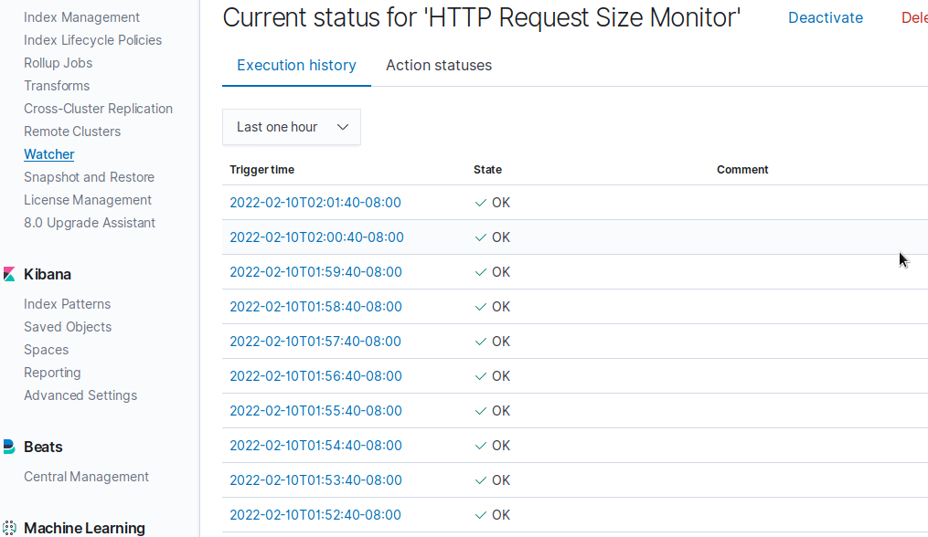

**CPU Usage Monitor**

CPU Usage Monitor is implemented as follows:

WHEN **max()** OF **system.process.cpu.total.pct** OVER **all documents** IS ABOVE 0.5 FOR THE LAST **5 minutes**

* Metric:
  + WHEN max() OF system.process.cpu.total.pct OVER all documents
* Threshold:
  + IS ABOVE 0.5
* Vulnerability Mitigated:
  + Malicious software, programs (malware or viruses) running taking up resources
* Reliability:
  + The alert is highly reliable. This alert can help see how to more efficiently use the CPU even if there isn’t a malicious program running.

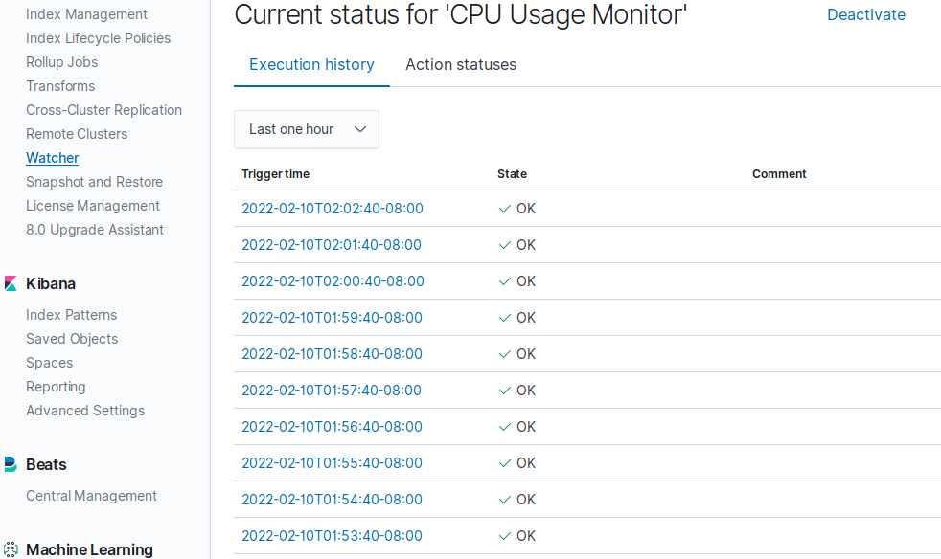

**Suggestions for Going Further**

Suggest a patch for each vulnerability identified by the alerts above.

Remember: alerts only detect malicious behaviour. They do not prevent it. It is not necessary to explain how to implement each patch.

The logs and alerts generated during the assessment suggest that this network is susceptible to several active threats. In addition to watching for occurrences of such threats, the network should be hardened against them. The Blue Team suggests that IT implement the fixes below to protect the network:

**Excessive HTTP Errors**

* Patch: WordPress Hardening
  + Implement regular updates to WordPress
    - WordPress Core
    - PHP version
    - Plugins
  + Install security plugin(s)
    - Ex. Wordfence (adds security functionality)
  + Disable unused WordPress features and settings like:
    - WordPress XML-RPC (on by default)
    - WordPress REST API (on by default)
  + Block requests to /?author= by configuring web server settings
  + Remove WordPress logins from being publicly accessible specifically:
    - /wp-admin
    - /wp-login.php
* Why It Works:
  + Regular updates to WordPress, the PHP version and plugins is an easy way to implement patches or fixes to exploits/vulnerabilities.
  + Depending on the WordPress security plugin it can provide things like:
    - Malware scans
    - Firewall
    - IP options (to monitor/block suspicious traffic)
  + REST API is used by WPScan to enumerate users
    - Disabling it will help mitigate WPScan or enumeration in general
  + XML-RPC uses HTTP as it’s method of data transport
  + WordPress links (permalinks) can include authors (users)
    - Blocking request to view the all authors (users) helps mitigate against user enumeration attacks
  + Removal of public access to WordPress login helps reduce the attack surface

**HTTP Request Size Monitor**

* Patch: Code Injection/DDOS Hardening
  + Implementation of HTTP Request Limit on the web server
    - Limits can include a number of things:
    - Maximum URL Length
    - Maximum length of a query string
    - Maximum size of a request
  + Implementation of input validation on forms
* Why It Works:
  + If an HTTP request URL length, query string and over size limit of the request a 404 range of errors will occur.
    - This will help reject these requests that are too large.
  + Input validation can help protect against malicious data anyone attempts to send to the server via the website or application in/across a HTTP request.

**CPU Usage Monitor**

* Patch: Virus or Malware hardening
  + Add or update to a good antivirus.
  + Implement and configure Host Based Intrusion Detection System (HIDS)
    - Ex. SNORT (HIDS)
* Why It Works:
  + Antiviruses specialise in removal, detection and overall prevention of malicious threats against computers.
    - Any modern antivirus usually covers more than viruses and is a robust solution to protecting a computer in general.
  + HIDS monitors and analyzes internals of computing systems.
    - They also monitor and analyse network packets.